

**Salesforce.com Facebook Channel Functional Design Document**

Version 1.3

January 24, 2014

**Copyright © 2014 Unisys Corporation**

**All rights reserved**

**Unisys Corporation Confidential**

**Revision History**

|  |  |  |  |
| --- | --- | --- | --- |
| Version | Date | Author | Summary of Changes |
| 1.0 | 1/24/2014 | Sreelatha SK | Initial draft |
| 1.1 | 2/5/2014 | Sreelatha SK | Incorporated review comments from Jim |
| 1.2 | 2/19/2014 | Sreelatha SK | Updated review comments from Kim and Graham  - Enable Auto-case creation changed to “No”  - Default *Twitter Service Request* type is added. |
| 1.3 | 6/9/2014 | Sreelatha SK | Adding to enable Salesforce for Facebook for non-Administrator Profiles |
|  |  |  |  |
|  |  |  |  |
|  |  |  |  |

**Reviewers**

| Name | Position |
| --- | --- |
|  |  |
| Kimberly Adams | City – Social Media SME |
| Graham Quinn | City – Social Media SME |
| Edward Garcia | City – Project Manager |
| James Robb | Unisys Project Manager |
| Rosetta Carrington Lue | City – 311 Director |
|  |  |
|  |  |
|  |  |

Table of Contents

Table of Contents 3

1 Overview 4

2 Pilot Implementation 4

2.1 Facebook Channel Functionality 4

3 Citywide Implementation 4

3.1 Facebook Channel Functionality 4

4 Assumptions 4

5 Supporting Business Rules 5

6 Facebook Customizations 5

7 Issues 6

8 Facebook Channel Integration Screenshots 6

8.1 Facebook Channel Integration Home page 6

8.2 Salesforce Instance for Facebook 7

8.3 Execute Facebook Search - Manually 8

8.4 Execute Facebook Search - Automatic 9

# Overview

This document defines the functionality needed to successfully implement Facebook for Philly311 CRM solution on SalesForce. The use case for Facebook functionality is to provide for the ability to create service requests in the SFDC Service Cloud from posts on the City’s Facebook Page, and send confirmations and other correspondence (such as customer satisfaction surveys) from the City.

# Pilot Implementation

## Facebook Channel Functionality

Unisys will implement in the SFDC Service Cloud the “Salesforce for Facebook app” from the Salesforce’s App Exchange to implement this functionality. Unisys will activate the following functionality in the SFDC platform for one (1) Facebook Page:

1. Download and review posts to on the City’s Facebook pages.
2. Create service requests may be created from posts on City’s Facebook Page in the SFDC Service Cloud.
3. Respond to constituents with posts.
4. Agent can use the SFDC Service Cloud to send confirmations or other correspondence such as customer satisfaction surveys after service request completion.
5. All the requests from Facebook to configure to *Facebook Service Requests* Case Record Type and routed to 311 Agents Queue. < *Facebook Service Requests* - is the default name and city can give the actual name required later>

# Citywide Implementation

## Facebook Channel Functionality

Unisys will configure five (5) additional “Facebook” pages in SFDC Service Cloud platform. The “Salesforce for Facebook” application from the SFDC App Exchange will be used to implement this function. Unisys will activate the following functionality in the SFDC Service Cloud platform:

1. Download and review posts to on the City’s Facebook pages.
2. Create service requests may be created from posts on City’s Facebook Page in the SFDC Service Cloud.
3. Respond to constituents with posts.
4. Agent can use the SFDC Service Cloud to send confirmations or other correspondence such as customer satisfaction surveys after service request completion.
5. All the requests from Facebook to configure to *Facebook Service Requests* Case Record Type and routed to 311 Agents Queue. < *Facebook Service Requests* - is the default name and city can give the actual name required later>

# Assumptions

The following table defines the assumptions of conditions that must be true for a successful implementation:

| **Assumption #** | **Assumption Description** | **Comments** |
| --- | --- | --- |
| ASSUMP1 | Unisys assumes that all Twitter tweets and Facebook posts will go to one common location for the Philly311 agents to process. |  |
| ASSUMP2 | The City of Philadelphia will provide Unisys with an administrator level access to the City’s Philly311 Facebook Account to complete the SFDC for Facebook installation. |  |
| ASSUMP3 | The City of Philadelphia will provide Unisys all (five number) the Facebook accounts details for integration. |  |

# Supporting Business Rules

The following defines the additional business rules needed for Facebook channel functionality in Salesforce.com.

| **Rule #** | **Business Rule Description** | **Comments** |
| --- | --- | --- |
| BRULE001 | **"SFDC for Facebook" app (from the App Exchange)** will be installed in the SFDC Service Cloud application to integrate Facebook and create service requests from this channel. | Service requests created via, social media technology, through a third party app **SFDC for Facebook** |
| BRULE002 | For each Facebook account, get separate bit.ly username and API key from the City and add within “SalesForce Social”. | Facebook username to be created by City at Facebook.com/signup.  After successful validation, refer Facebook page and user validation here. |
| BRULE003 | 311 Agents should have access to ‘Social Agent’ Page only but not for ‘Salesforce Social’ page | 311 Agents able to send messages, but do not have access the setup page, troubleshooting logs, etc. Refer for sample Social Agent page. |
| BRULE004 | Setting up Knowledge Base Integration by setting up bit.ly (used for shortening Articles URLs) and automatic Agent Signatures | This allows replying to Facebook questions with links Articles City’s Salesforce Knowledge base.  In addition, Knowledge base Articles should be published to City’s public Knowledge base. |

# Facebook Customizations

The following defines the custom changes needed for Facebook channel functionality in Salesforce.com.

| **Custom field** | **Field value** | **Custom setting Explanation** |
| --- | --- | --- |
| **Facebook Fan Page for Facebook Account:** | | |
| Authorize Facebook Fan Page for Facebook Account | Admin User | Uses a standard Facebook user account with Administrator privileges to  maintain the Facebook Page |
| Page Admin | This is the person whom created the Facebook Fan Page. |
| Setup for accessing Facebook Fan page | Enable OAuth | Required for successfully performing the “Grant Facebook Access” |
| Allow interaction on Facebook Fan Page to | Unknown Users | To create a new Contact, Lead, or Person Account for each new Post or Comment |
| Run Case Association Logic | This will create a Case for the original conversation created by each new Post on Facebook, and associate that Conversation, and any subsequent Conversations associated with Comments (replies to the first Post), to the Case |
| Add Posts with #ch to Chatter | posts by the Facebook Fan Page, containing #ch, will be posted to the Chatter feed of the owner of the Fan Page record in Salesforce |
| Fan Page’s OAUTH to be reset | Reset required | To revoke authorization for validated fan pages |
| Manual Search Required | Yes | Follow the screen for manual search |
| Automated Search Setting | ‘Time Interval’ = 15 minute (default) | Set ‘Time Interval’ (Facebook Fan Page search) |
| **Customization of Sidebar Links:** | | |
| Sidebar links | Schedule Searches | Click on this link to set up automated searches in Philadelphia org |
|  |  |
| Schedule Searches | Click on this link to set up automated searches in Philadelphia org |
| Review Setup Guide | Click on this link to access a copy of this setup guide |
| Dashboard & Analytics | Click on this link to view a set of predefined Dashboards and Analytics related to the Salesforce for Facebook application |
| Troubleshooting Log | The troubleshooting log contains a record of all manual and automated searches that were run in Salesforce for Facebook application |
| Language and Translation | <English> | Salesforce for Facebook supports all foreign language character sets in both incoming and outgoing Tweets – including Japanese, Hebrew, and all European character sets. |
| Facebook messages configured as Cases in SalesForce.com | Manual | Generally all messages on Facebook are not SRs and some may be comments. In SalesForce, all are treated as Cases. Manual review of the social media input is required. |
| **Customization for enabling Salesforce for Facebook for Non-Administrator:** | | |
| Enabling Salesforce for Facebook for non-Administrator Profiles | Custom App Settings | Salesforce for Facebook app settings:  Check the “Visible” checkbox |
| Custom Tab Settings | Facebook Conversations = ‘Default On’ |
| Enable Visualforce Page Access | Add all pages prefix with ‘Fcbk’ |

# Issues

The following defines the Issues for Facebook channel functionality in Salesforce.com.

| **Rule #** | **Issue Description** | **Comments** |
| --- | --- | --- |
|  |  |  |

# Facebook Channel Integration Screenshots

## Facebook Channel Integration Home page



## Salesforce Instance for Facebook

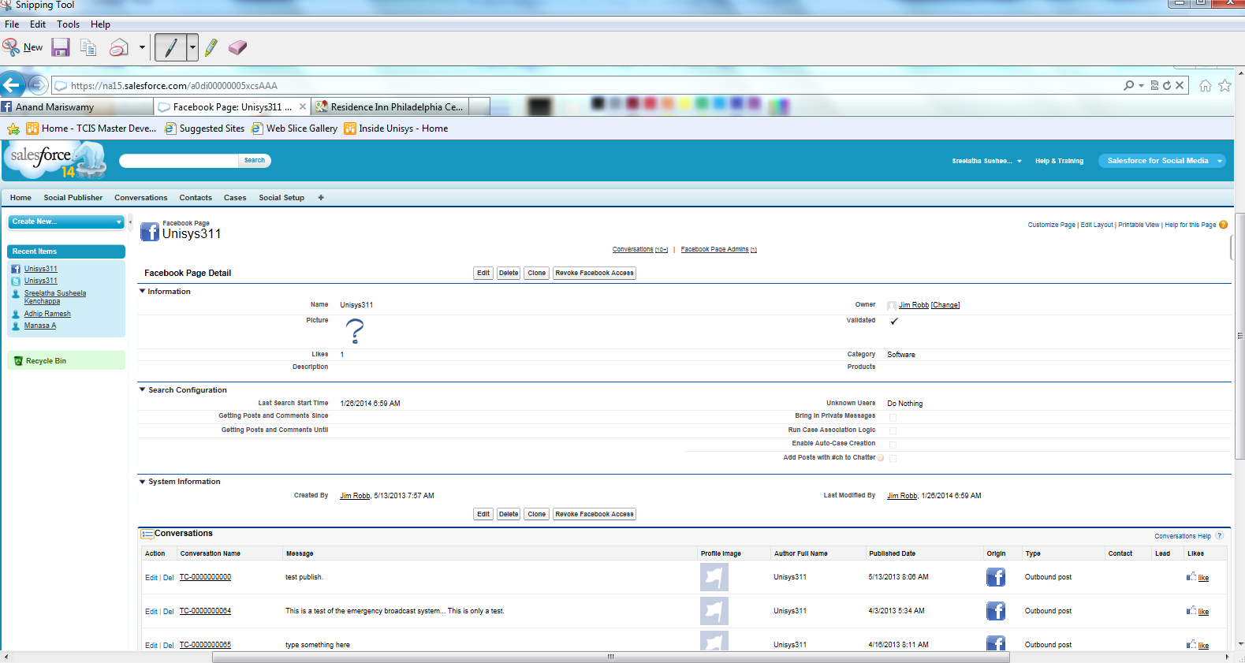

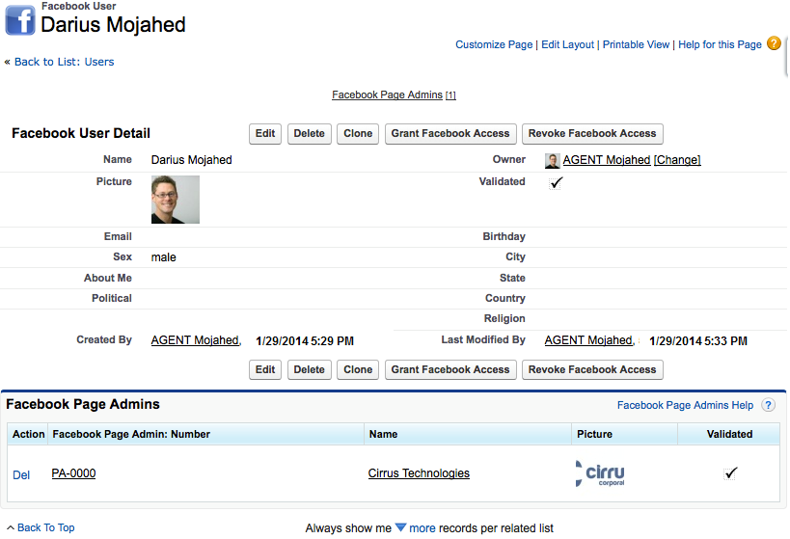

## Execute Facebook Search - Manually



## Execute Facebook Search - Automatic

